P. Lakshmivani
192365018
CSA1013

CO4 ASSESSMENT TOOL 2 – CI/CD PIPELINE DESIGN EXERCISE
Smart Cold Storage Monitoring and Food Preservation System
Field | Details | Field | Details
Course Code | CSA1013 | Course Title | Software Engineering
CO Assessed | CO4 | Assessment | Assessment Tool 2 – CI/CD Pipeline Design Exercise
Weightage | 20% | Total Marks | 25
Student Name | P. lakshmivani | Reg. No. | 192365018
Date | 19-08-2026 | Duration | 60 minutes
ASSESSMENT QUESTION
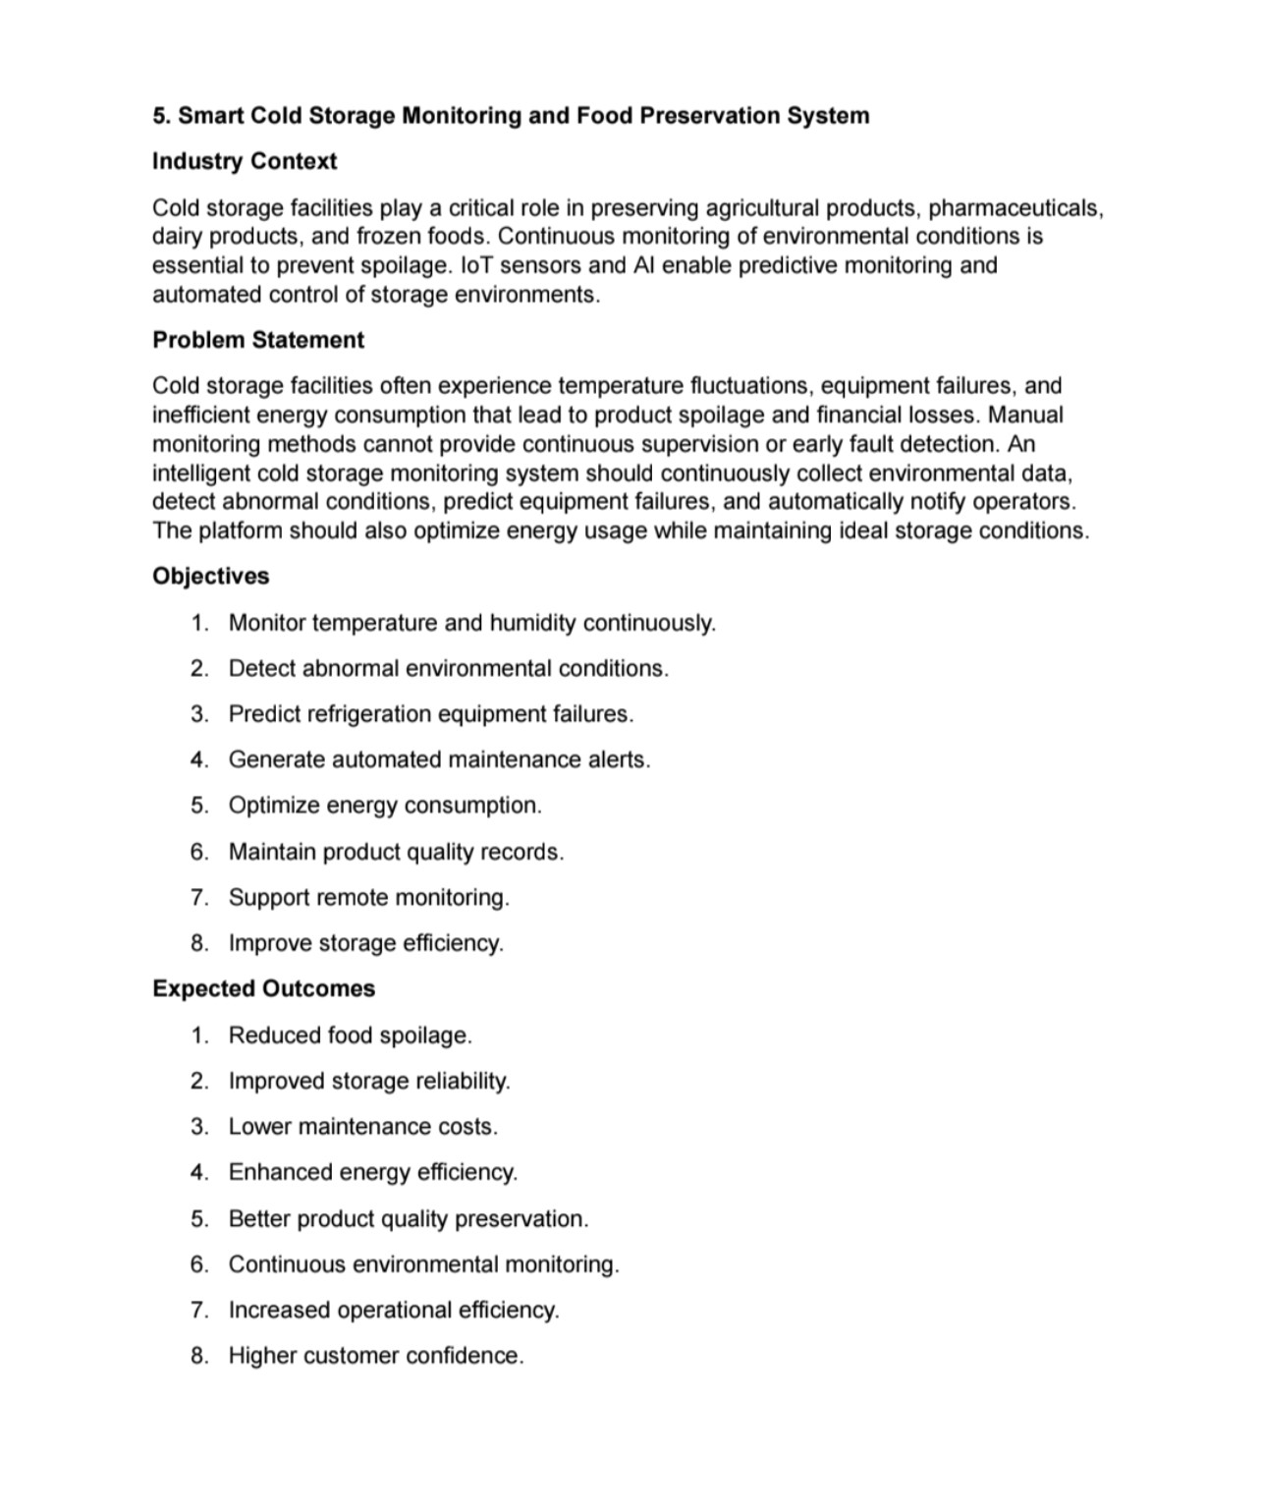
CI/CD Pipeline Design for the assigned Smart Cold Storage Monitoring and Food Preservation System.

1. Requirement & CI/CD Analysis
1.1 Project Requirements
ID | Requirement | CI/CD Relevance
R01 | Continuous monitoring | Temperature and humidity data must be collected continuously.
R02 | Real-time alerts | Abnormal environmental conditions must generate alerts.
R03 | Historical records | Environmental and product-quality records must be stored.
R04 | Predictive maintenance | Historical data should support refrigeration failure prediction.
R05 | Remote monitoring | Authorized operators should monitor storage status remotely.
R06 | Energy optimization | Energy-related data should support efficient operation.
R07 | Reliability | Monitoring should recover safely from sensor/network failures.
R08 | Security | Only authorized users/services should access protected resources.
1.2 CI/CD Needs
• Automated source-code integration after every change.
• Automated build to identify compilation or dependency errors.
• Automated unit and integration testing for monitoring and alert functions.
• Code-quality and security checks before deployment.
• Container image packaging for a consistent runtime.
• Separate development, staging and production environments.
• Deployment approval and rollback mechanisms.
• Notifications when builds, tests or deployments succeed or fail.
1.3 Expected CI/CD Benefits
The pipeline should reduce manual deployment effort, detect defects earlier, improve release consistency, support reliable updates and provide traceability from a code change to a deployed version.

2. CI/CD Pipeline Architecture & Workflow
2.1 Proposed Pipeline
Code Commit → Source Validation → Build → Unit Tests → Integration Tests → Code Quality → Security Scan → Package/Containerize → Staging Deployment → Acceptance Tests → Production Approval → Production Deployment → Monitoring → Rollback if Required.
2.2 Pipeline Stages
Stage | Name | Tool/Area | Purpose
1 | Source | Git repository | Trigger pipeline when code is committed or a pull request is created.
2 | Build | CI runner | Install dependencies and build the application.
3 | Unit Test | Test framework | Validate individual modules.
4 | Integration Test | Test environment | Verify API, database and service interaction.
5 | Quality | Static analysis | Check code quality, style and maintainability.
6 | Security | SAST/dependency scanner | Identify vulnerable code and dependencies.
7 | Package | Docker | Create a versioned container image.
8 | Staging | Docker/Compose | Deploy candidate version for validation.
9 | Acceptance | Automated tests | Verify important user/system workflows.
10 | Production | Deployment platform | Deploy approved image.
11 | Monitor | Logs/metrics | Observe health, errors and performance.
2.3 Workflow Explanation
A developer commits code to the Git repository. The CI system automatically builds the application and runs tests. If quality or security checks fail, the pipeline stops and reports the failure. A successful build is packaged as a Docker image and deployed to staging. After acceptance validation and approval, the same versioned artifact is deployed to production. Monitoring continues after deployment, with rollback available when a release causes critical problems.

3. Tools & Technology Selection
Tool | Stage | Use | Justification
GitHub | Source Control | Stores source code, branches, pull requests and history. | Provides collaboration and traceability.
GitHub Actions | CI/CD | Runs automated workflows on repository events. | Integrated with GitHub and suitable for automated builds/tests.
Docker | Packaging | Builds a consistent application container image. | Provides portability and repeatable deployment.
Docker Compose | Local/Staging | Runs application and database services together. | Simplifies multi-service environments.
Python/Java test framework | Testing | Runs unit and integration tests. | Automates functional validation.
SonarQube | Code Quality | Performs static code-quality analysis. | Identifies maintainability issues.
Trivy | Security | Scans container images/dependencies. | Helps identify known vulnerabilities.
Artifact Registry | Package Storage | Stores versioned container images. | Allows the exact tested image to be deployed.
Monitoring/Logs | Operations | Tracks application health and failures. | Supports quick detection and recovery.
3.1 Tool Selection Principles
• Prefer tools that integrate with the repository.
• Automate repetitive build and test activities.
• Use reproducible container images.
• Keep secrets outside source code.
• Use versioned artifacts so rollback is possible.

4. Automated Testing & Quality Integration
4.1 Testing Strategy
Test Type | Coverage | When
Unit Testing | Sensor validation, threshold logic, alert rules, utility functions. | Every code change.
Integration Testing | Backend, database, sensor-data API and alert interaction. | Pull request / main branch.
System Testing | Complete monitoring workflow. | Staging deployment.
Security Testing | Authentication, authorization and dependency/image scanning. | Pull request and release.
Performance Testing | Dashboard/API response and historical-data processing. | Scheduled/release testing.
Regression Testing | Previously working functions after new changes. | Every release.
4.2 Pipeline Quality Gates
• Build must complete successfully.
• Unit tests must pass.
• Integration tests must pass.
• Critical code-quality issues must be resolved.
• High-severity security vulnerabilities must block release.
• Docker image must build successfully.
• Staging acceptance tests must pass before production.
4.3 Example Pipeline Test Flow
1. Developer creates a feature branch.
2. Code is committed and pushed.
3. CI starts automatically.
4. Build and unit tests execute.
5. Integration, quality and security checks execute.
6. Pipeline stops if a required quality gate fails.
7. Successful code produces a versioned container image.

5. Deployment Strategy
5.1 Environment Design
Environment | Purpose | Activities | Access
Development | Developer testing | Frequent code changes and basic automated tests. | No production users.
Staging | Pre-production validation | Production-like configuration and acceptance testing. | Restricted access.
Production | Live monitoring system | Approved and tested container image. | Protected and monitored.
5.2 Deployment Process
1. Build the application from the selected commit.
2. Run automated tests and quality/security checks.
3. Build and tag the Docker image using a version identifier.
4. Push the image to the artifact/container registry.
5. Deploy the exact image to staging.
6. Run acceptance tests.
7. Obtain production approval when required.
8. Deploy the same tested image to production.
9. Monitor application health after deployment.
5.3 Deployment Strategy
A rolling or blue-green deployment can be used when the infrastructure supports it. For a smaller academic implementation, a controlled deployment using a versioned Docker image is sufficient. The key principle is that production should receive the same artifact that successfully passed staging.

6. Security, Notifications & Rollback
6.1 Security Practices
• Store repository and deployment credentials as CI/CD secrets.
• Never commit database passwords, API keys or private tokens.
• Use dependency and container vulnerability scanning.
• Restrict production deployment permissions.
• Use protected main/release branches.
• Review pull requests before merging.
• Use HTTPS and secure authentication for remote monitoring.
• Keep dependencies and base images updated.
6.2 Notifications
Event | Notification | Purpose
Build failed | Team notification | Prompt developer correction.
Tests failed | Team notification | Prevent defective code from progressing.
Security gate failed | Security/developer alert | Block risky release.
Staging successful | Release notification | Indicate readiness for approval.
Production deployed | Deployment notification | Confirm release.
Rollback executed | Critical alert | Inform team about recovery action.
6.3 Rollback Strategy
Every production release should use a unique image tag such as v1.0.0 or a commit-based identifier. If monitoring shows critical errors after deployment, the previous known-good image can be redeployed. Database changes should be backward compatible where possible so application rollback does not corrupt stored records.
6.4 Recovery
After rollback, the team should inspect logs, identify the failure, create a corrective change, run the complete pipeline again and redeploy only after the quality gates pass.

7. CI/CD Pipeline Diagram & Configuration
7.1 Pipeline Diagram
┌──────────────────────┐
│ Developer / Team │
└──────────┬───────────┘
│ git push / pull request
▼
┌──────────────────────┐
│ Git Repository │
└──────────┬───────────┘
▼
┌──────────────────────┐
│ Build │
└──────────┬───────────┘
▼
┌──────────────────────┐
│ Unit + Integration │
│ Tests │
└──────────┬───────────┘
▼
┌──────────────────────┐
│ Quality + Security │
│ Gates │
└──────────┬───────────┘
▼
┌──────────────────────┐
│ Docker Image │
└──────────┬───────────┘
▼
┌──────────────────────┐
│ Staging Deployment │
└──────────┬───────────┘
▼
┌──────────────────────┐
│ Acceptance Tests │
└──────────┬───────────┘
▼
┌──────────────────────┐
│ Production Approval │
└──────────┬───────────┘
▼
┌──────────────────────┐
│ Production │
└──────────┬───────────┘
▼
┌──────────────────────┐
│ Monitoring / Alerts │
└──────────┬───────────┘
│ failure
▼
Rollback to
known-good image
7.2 Example Workflow Configuration
name: cold-storage-ci-cd
on:
push:
branches: [main, development]
pull_request:
jobs:
build-test:
runs-on: ubuntu-latest
steps:
- uses: actions/checkout@v4
- run: pip install -r requirements.txt
- run: pytest
- run: docker build -t cold-storage:${{ github.sha }} .
deploy-staging:
needs: build-test
if: github.ref == 'refs/heads/development'
runs-on: ubuntu-latest
steps:
- run: echo "Deploy tested image to staging"
deploy-production:
needs: build-test
if: github.ref == 'refs/heads/main'
runs-on: ubuntu-latest
steps:
- run: echo "Deploy approved image to production"

8. Pipeline Workflow & Quality Attributes
8.1 Stage-to-Requirement Traceability
Requirement | Pipeline Stage | Coverage
R01 | Build + Unit + Integration Tests | Continuous monitoring changes are validated.
R02 | Unit + Integration + Acceptance Tests | Alert behavior is checked before release.
R03 | Integration Tests | Database record operations are validated.
R04 | Analytics Tests | Prediction functionality is validated when changed.
R05 | Security + System Tests | Remote access and authentication are tested.
R06 | Integration/Performance Tests | Energy data processing is validated.
R07 | Failure/Recovery Tests | Service recovery is tested.
R08 | Security Scanning + Protected Deployment | Security checks and access control are applied.
8.2 Quality Attributes
Attribute | CI/CD Mechanism | Expected Benefit
Reliability | Automated tests, health checks, rollback | Fewer failed releases.
Security | Secret management, scanning, protected branches | Reduced security risk.
Maintainability | Quality analysis and code review | Cleaner codebase.
Portability | Docker images | Consistent deployment.
Scalability | Containerized services | Easier service expansion.
Availability | Monitoring and rollback | Faster recovery.
Traceability | Git commits + versioned images | Release history is clear.
8.3 Failure Handling
If any mandatory stage fails, the pipeline should stop. The developer receives a failure notification, corrects the problem and pushes a new change. Production deployment should never proceed when required tests or security gates fail.

9. Deployment, Security & Rollback Summary
9.1 Release Checklist
• Code reviewed and merged into the correct branch.
• Build completed successfully.
• Unit and integration tests passed.
• Code-quality checks passed.
• Security/dependency/container scans passed.
• Docker image created with a unique version.
• Staging deployment completed.
• Acceptance tests passed.
• Production approval obtained when required.
• Production deployment monitored.
• Rollback plan available.
9.2 Challenges
• Managing hardware/sensor-specific dependencies in CI.
• Testing real-time IoT behavior in an automated environment.
• Handling database migrations safely.
• Keeping CI secrets secure.
• Managing Docker image size and dependency updates.
• Handling intermittent network conditions.
• Ensuring rollback compatibility with database changes.
9.3 Future Improvements
• Add automated infrastructure provisioning.
• Introduce advanced observability with centralized logs and metrics.
• Add automated performance testing.
• Use blue-green or canary deployment for production.
• Add signed container images and stronger supply-chain security.
• Integrate predictive-model validation into the pipeline.
• Add automatic rollback based on health metrics.
10. Conclusion
The proposed CI/CD pipeline automates the integration, building, testing, quality validation, security checking, packaging and deployment of the Smart Cold Storage Monitoring and Food Preservation System. Git provides controlled source-code management, while automated CI/CD ensures that changes are validated before reaching production.
The design uses development, staging and production environments, automated testing, Docker-based packaging, security gates, notifications, monitoring and rollback. This approach supports the CO4 focus on robust testing, quality assurance and DevOps practices with emphasis on security, reliability and maintainability.
11. Submission Checklist
• Add student name, registration number and date.
• Include the CI/CD architecture diagram.
• Include pipeline configuration/workflow.
• Add relevant screenshots if available.
• Verify testing and security stages.
• Document deployment and rollback procedure.
• Review formatting before submission.

